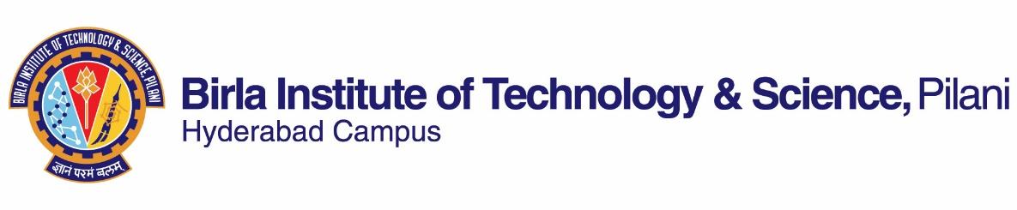

**SECOND SEMESTER 2021-2022**

# Course Handout Part II

Date: 31-12-2021

In addition to Part-I (General Handout for all courses appended to the time table) this portion gives further specific details regarding the course.

*Course No.* : **BITS G661**

## Course Title : **Research Methodology I**

## Instructor-in-Charge : Dr. **Satyapaul A. Singh**

*Instructors* : **Dr. Debirupa Mitra**

**Scope and Objective of the Course:**

This course introduces the student to the scientific method of conducting research and will provide a practical framework on which a student can base his/her research. The objective of this course is to inculcate a systematic approach to research including formulating a research topic, testable hypothesis, designing experiments, collecting and analyzing data and presenting their research in the form of reports, articles, thesis and seminars. The course also introduces the student to various analytical instruments and equipment commonly used in research laboratories as well as tools for data analysis. As part of the course, students will work on projects in which they can integrate the concepts learnt in class.

**Textbooks:**

1. C.George Thomas “Research Methodology and Scientific Writing”, Ane Books Pvt. Ltd., 2015.

**Course Plan:**

| **Lecture No.** | **Learning objectives** | **Topics to be covered** | **Chapter in the Text Book** |
| --- | --- | --- | --- |
| 1-2 | Describe the elements of research and the scientific method | Need for academic research  Introduction to the scientific method  Research methodology and research methods | 1 |
| 3 | Identify the approaches to research  Differentiate between types of research | Formal and informal approaches to research  Basic versus applied research,  Qualitative and Quantitative research, Experimental research, Variables in research | 3 |
| 4-11 | Formulate a hypothesis  Design experiments using statistical tools  Understand the significance of controls | Cause effect relationships, hypothesis, experiments, errors, use of controls,  Statistical design of experiments, Taguchi methods  Framing a hypothesis | 4, 5 |
| 12-20 | Collect relevant data  Analyze data using statistical tests  Represent data appropriately in tables, graphs, etc. | Data collection and record keeping  Data analysis  Statistics – commonly used tests, Grey relational analysis (GRA)  Representing data – tables versus figures  Illustrations, Types of graphs  Use of tools such as MS Excel, Origin | 6, 11 |
| 21-24 | Carry out a thorough literature review and summarize  Identify and use tools to store and organize literature | Importance of reviewing the literature  Sources available  Locating relevant literature  Reliability of sources  Note making, Paraphrasing, Writing a review  Citing literature | 8, 12 |
| 25-30 | Write a paper  Describe the elements of a journal article, thesis  Make clear and well defined presentations  Present ideas, data and results in a forum | Scientific writing – grammar, writing styles,  Writing research papers, review papers, thesis  Selecting a journal  Editing, formatting, Referencing  Review and peer review, Proofreading  Presentations, posters, How to present in seminars | 10, 13, 14 |
| 31 | Understand the ethical aspects of research | Ethics in research, Plagiarism  Intellectual Property Rights  Unscientific practices, Whistle blowing | 15 |
| 32-40 | Explain the principle involved in various analytical instruments and equipment | Demonstrations of equipment such as DSC, TGA, FTIR, Microscopes, spectrophotometer, chromatography systems, UTM, XRD, XRF, SEM and others. Analysis of data and images. | Lab manuals |

**Evaluation Scheme:**

| **Component** | **Duration** | **Weightage (%)** | **Date & Time** | **Nature of Component** |
| --- | --- | --- | --- | --- |
| Mid term | 90 minutes | 25% | TBA | OB |
| Assignments | TBA | 20% | TBA | OB |
| Seminars | TBA | 15% | TBA | OB |
| Comprehensive Examination | 2 hrs | 40% | TBA | OB |

**Academic Honesty and Integrity Policy**: Academic honesty and integrity are to be maintained by all the students throughout the semester and no type of academic dishonesty is acceptable

**Chamber Consultation Hour:** TBA

**Notices:** Will be uploaded on CMS website

**Make-up Policy:** Make up will only be granted for genuine reasons and only with prior permission.

**Academic Honesty and Integrity Policy:** Academic honesty and integrity are to be maintained by all the students throughout the semester and no type of academic dishonesty is acceptable.

**Dr. Satyapaul A. Singh**

**INSTRUCTOR-IN-CHARGE**